Event Name: Awareness Camp on : “Harmful effects of Single Use Plastic and Radiations: Remedial Measures”
Event Date: 14th March 2022 (Monday).
Event Venue/ Time : Village Daroli Kalan (at Gurudwara Dhan Dhan Shaheed Baba Mati JI) from 11:30am to 2:00pm
Organizing Unit/Agency: Department of Physical Sciences, University Institute of Sciences (Under the aegis of IQAC)
Number of Participant:60

Activity Report:
- Department of Physical Sciences, University Institute of Sciences, Sant Baba Bhag Singh University, Jalandhar have organized an awareness camp on “Harmful effects of Single Use Plastic and Radiations: Remedial Measures” in village Daroli Kalan, Jalandhar in Gurudwara Shaheed Baba Mati Ji on 14th March 2022.
- Dr. Nisha Sharma (Coordinator, Physical Sciences, Dr Mithu Maiti Jana (Co-Coordinator, Physical Sciences), Ms Arwinder Kaur(Assistant Professor, Physical Sciences), Ms Amarjeet Kaur(Assistant Professor, Physical Sciences), Ms Avneet Pal Kaur(Assistant Professor, Physical Sciences), Ms Baljinder Kaur(Assistant Professor, Physical Sciences), Ms Meena(Assistant Professor, Physical Sciences) and Mr Jujhar Singh (Assistant Professor, Physical Sciences) have conducted this drive.
- Students and faculty of Physical sciences have conducted an awareness rally in SBBSU campus and then extended at village Daroli Kalan.
- During this awareness drive, students and faculty have provided awareness regarding harmful effects of single use plastic, harmful effects of radiations for which we are exposed regularly.
- Possible remedial measures to minimize radiation exposure from electronic items have also been discussed.
- Students have guided the locals regarding management of single use plastic; how to segregate and recycle plastic in the form of useful decorative and other materials.
- Students also have demonstrated it through displaying some plastic based articles such as pen stand, hanging flower pots, festival articles and eco-bricks.
- Question /answer session have also been carried out.
- This awareness campaign is very fruitful for all and is highly appreciated by the audience.
- The event was concluded with vote of thanks to all for sparing their valuable time and participated enthusiastically.
- Gurudwara committee members honored all faculty members & appreciate the effort of students of SBBSU for organizing such activities
Some glimpse of the activity are as follows:
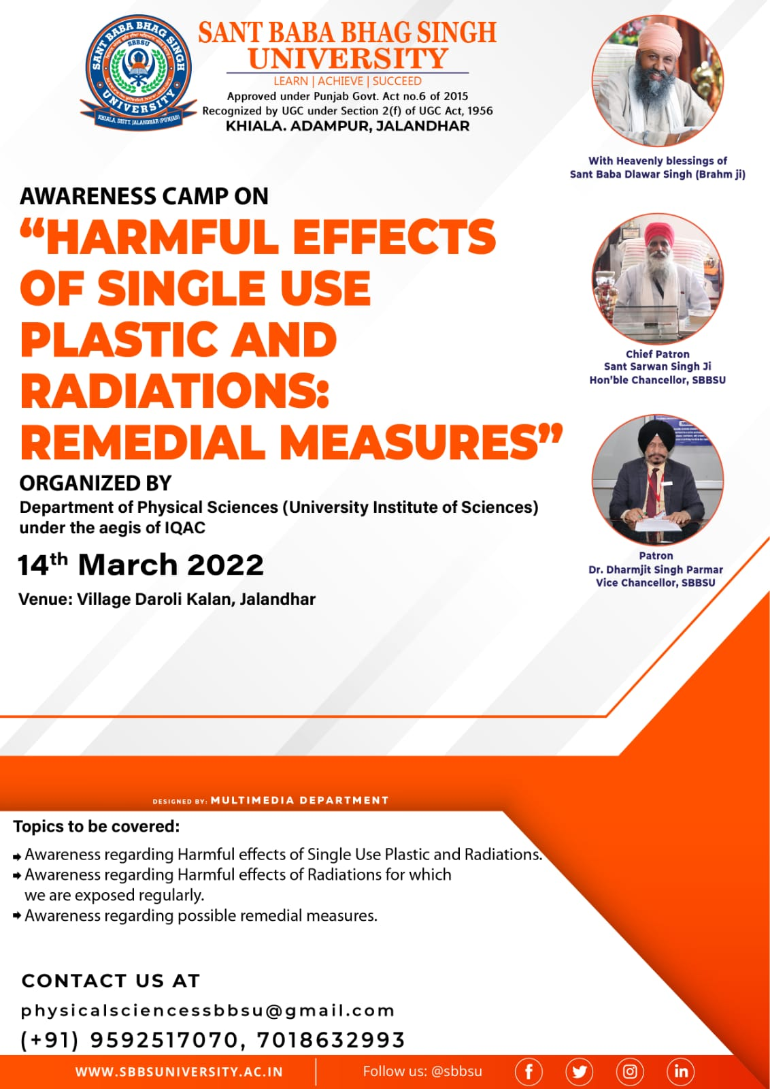

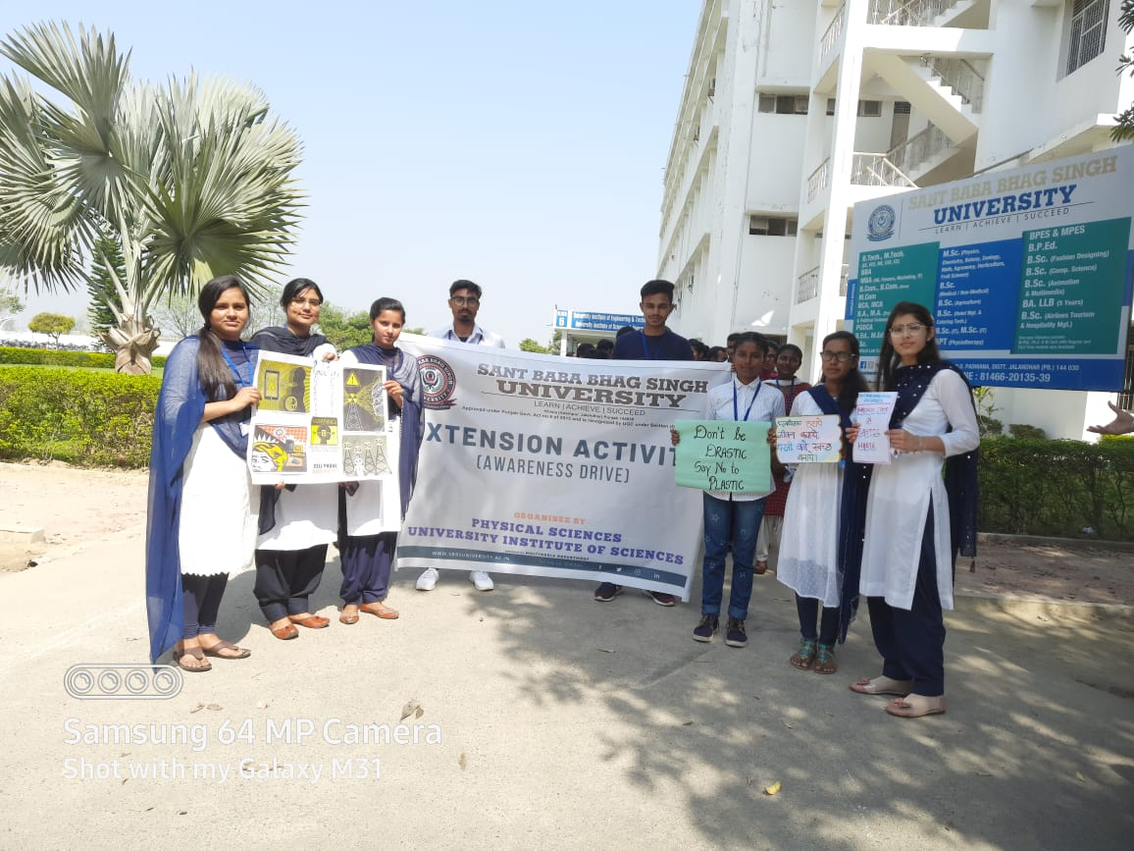
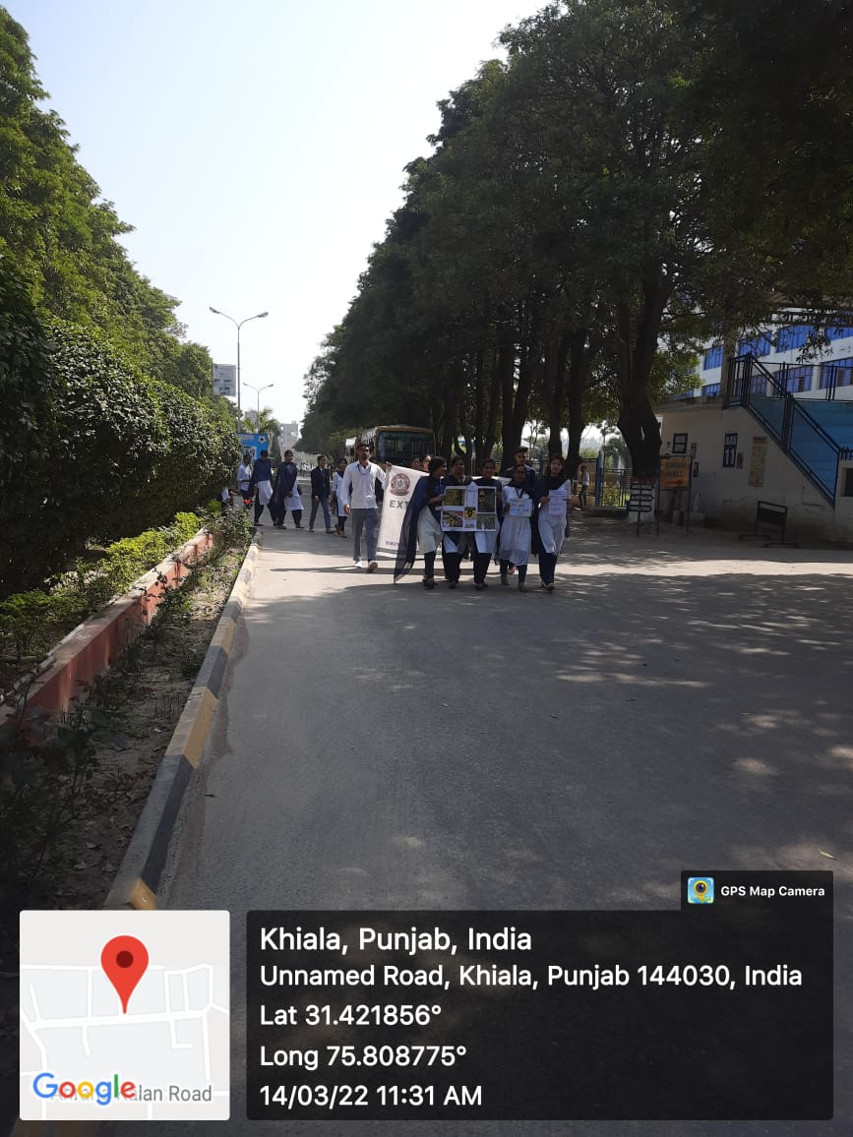
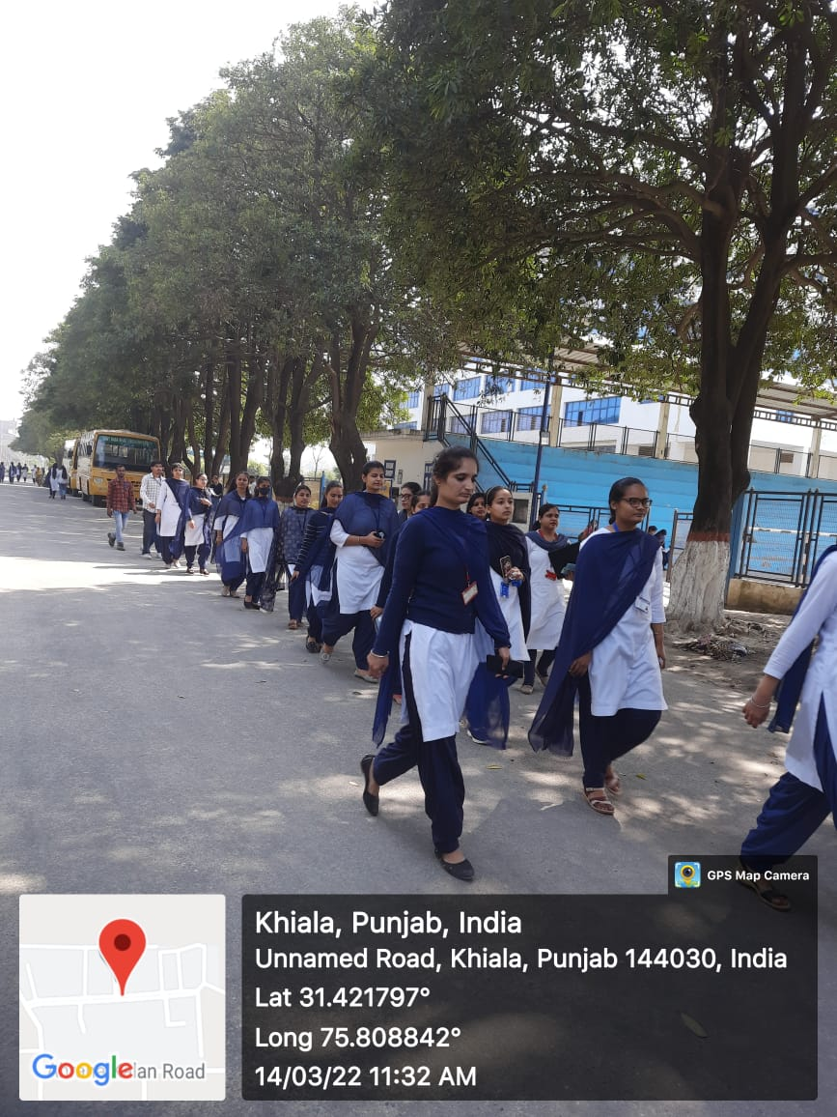

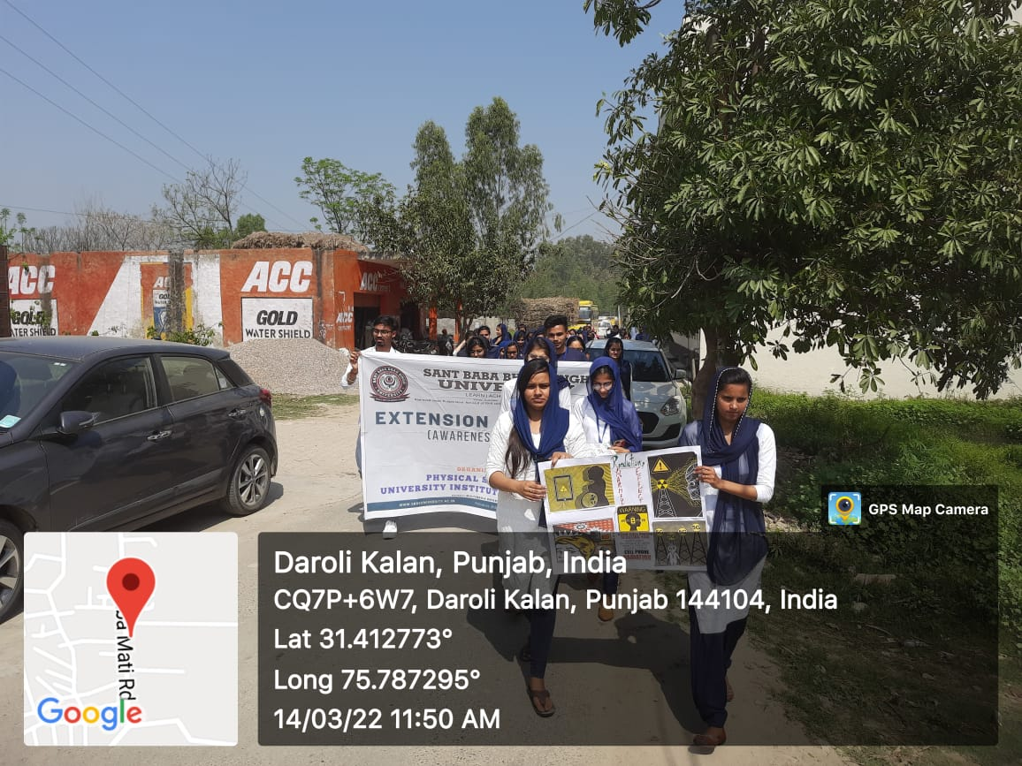

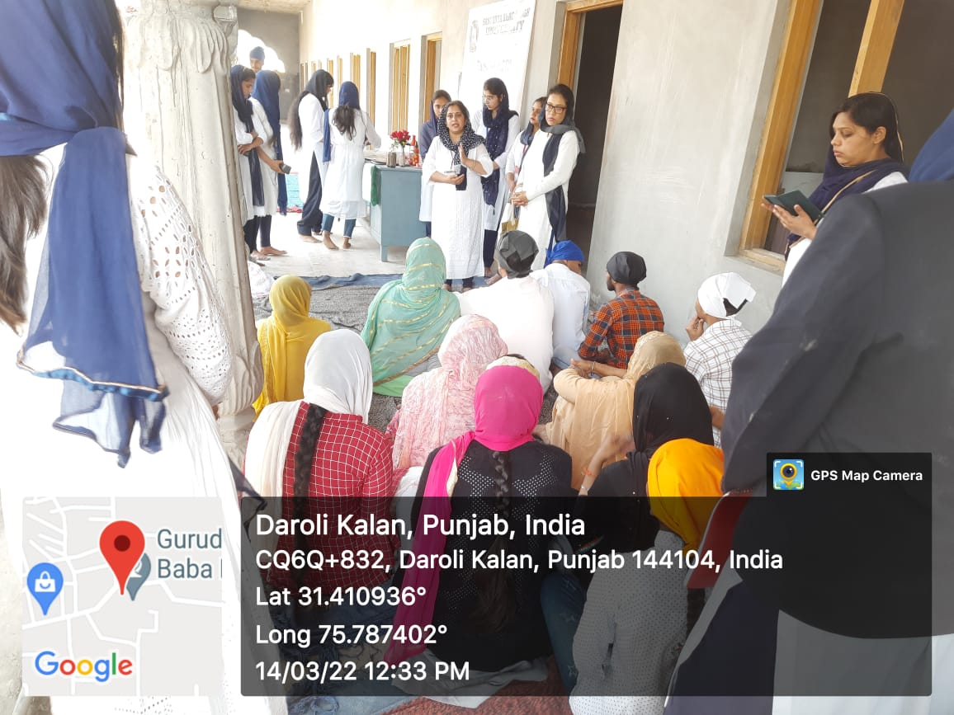
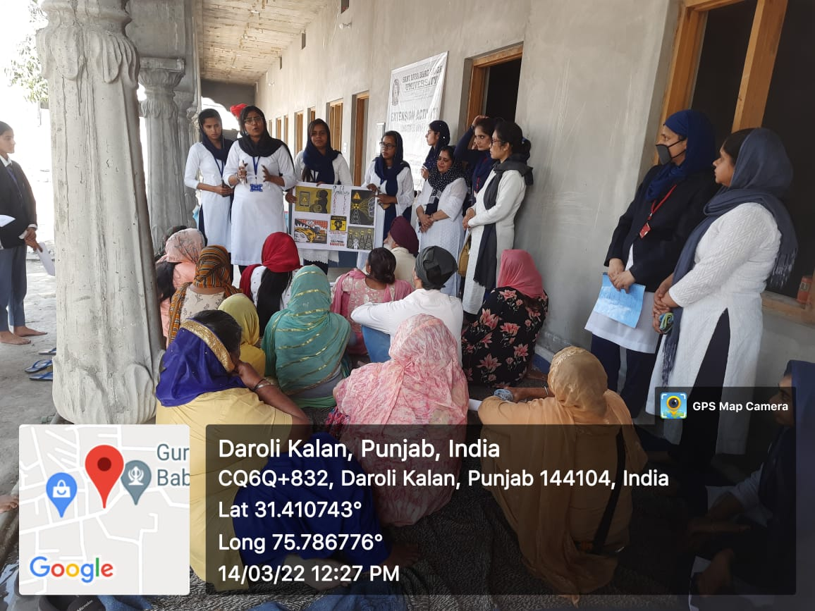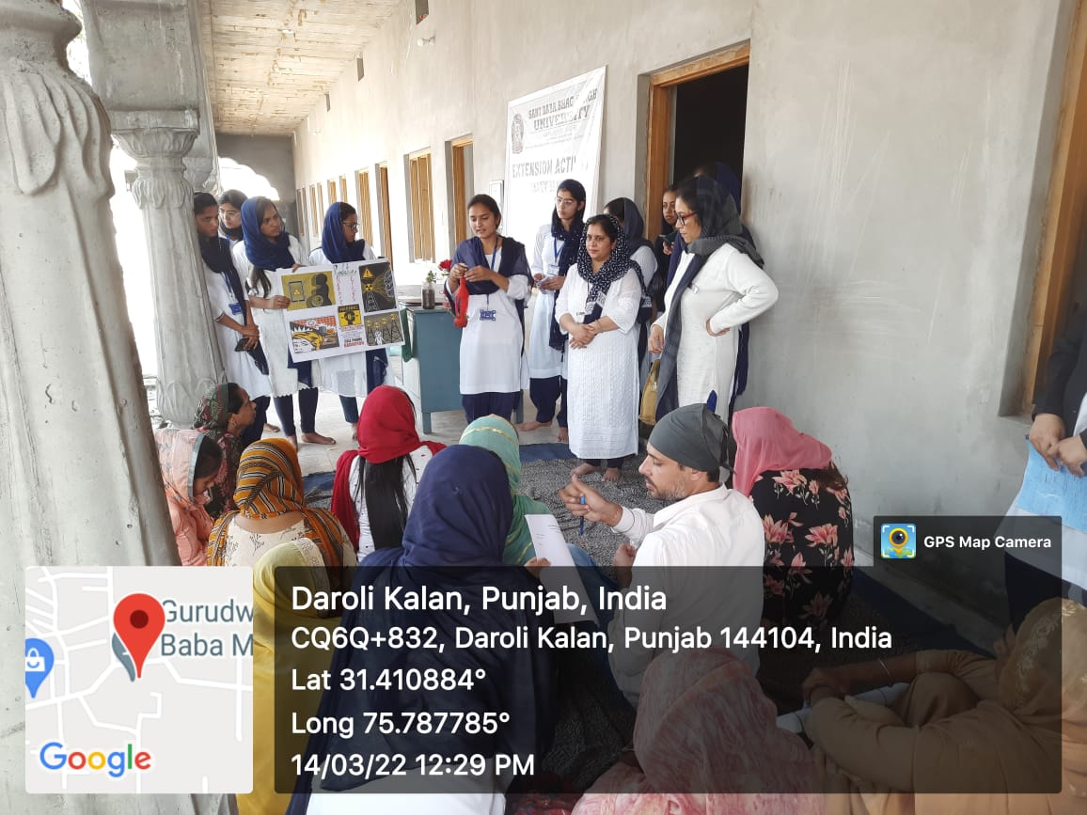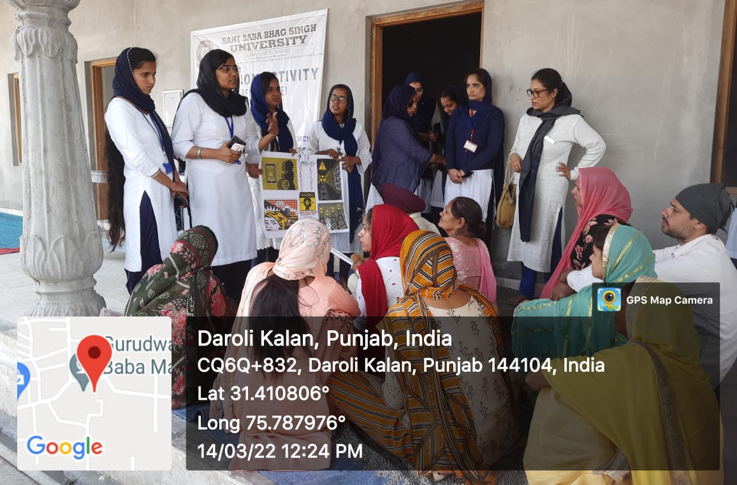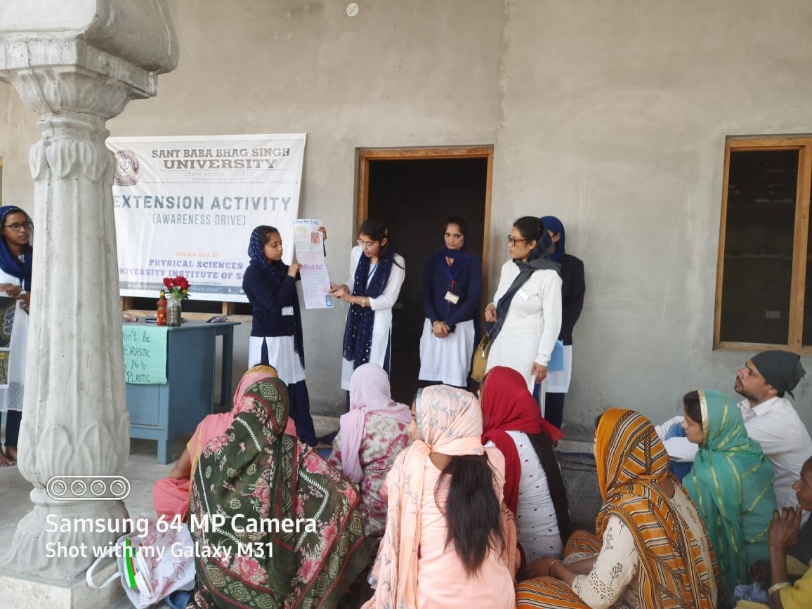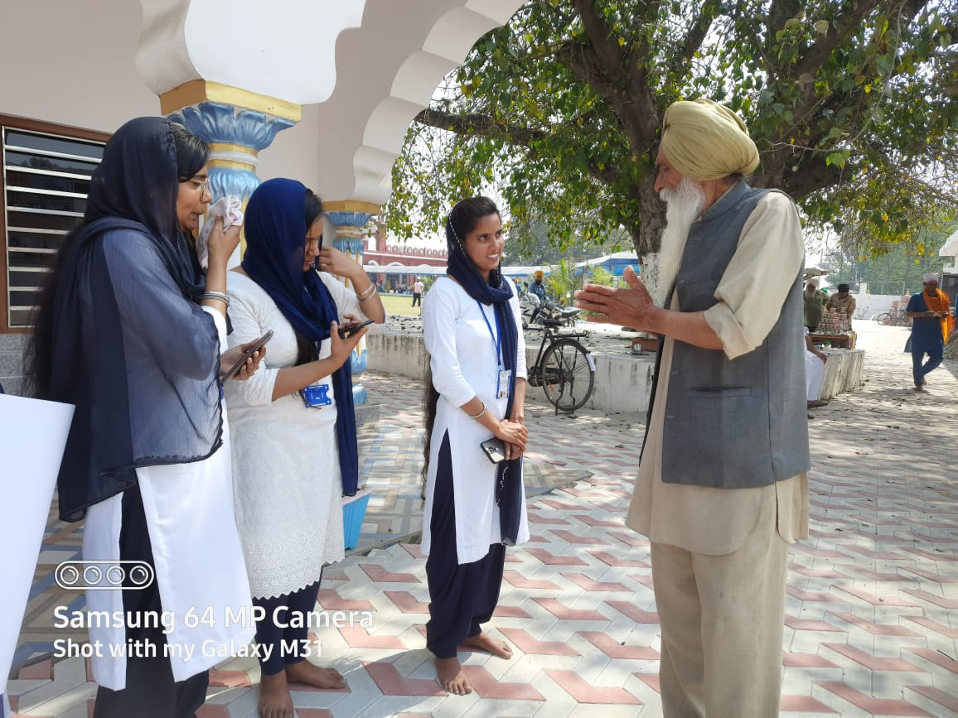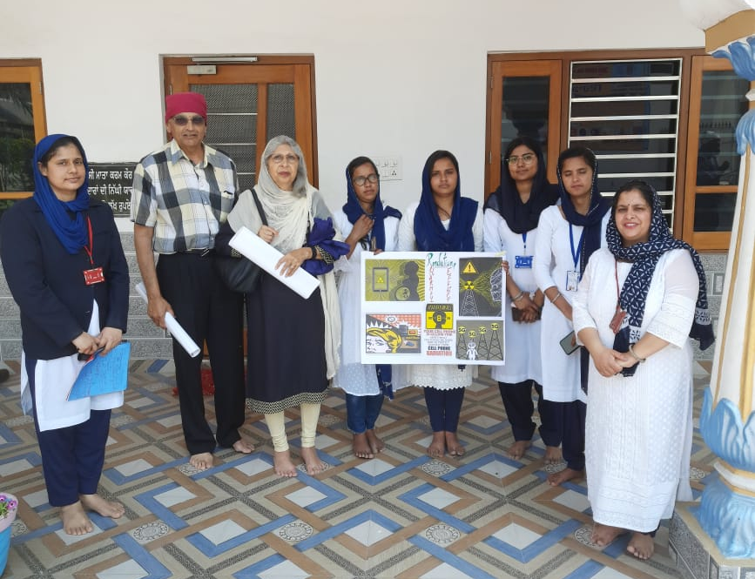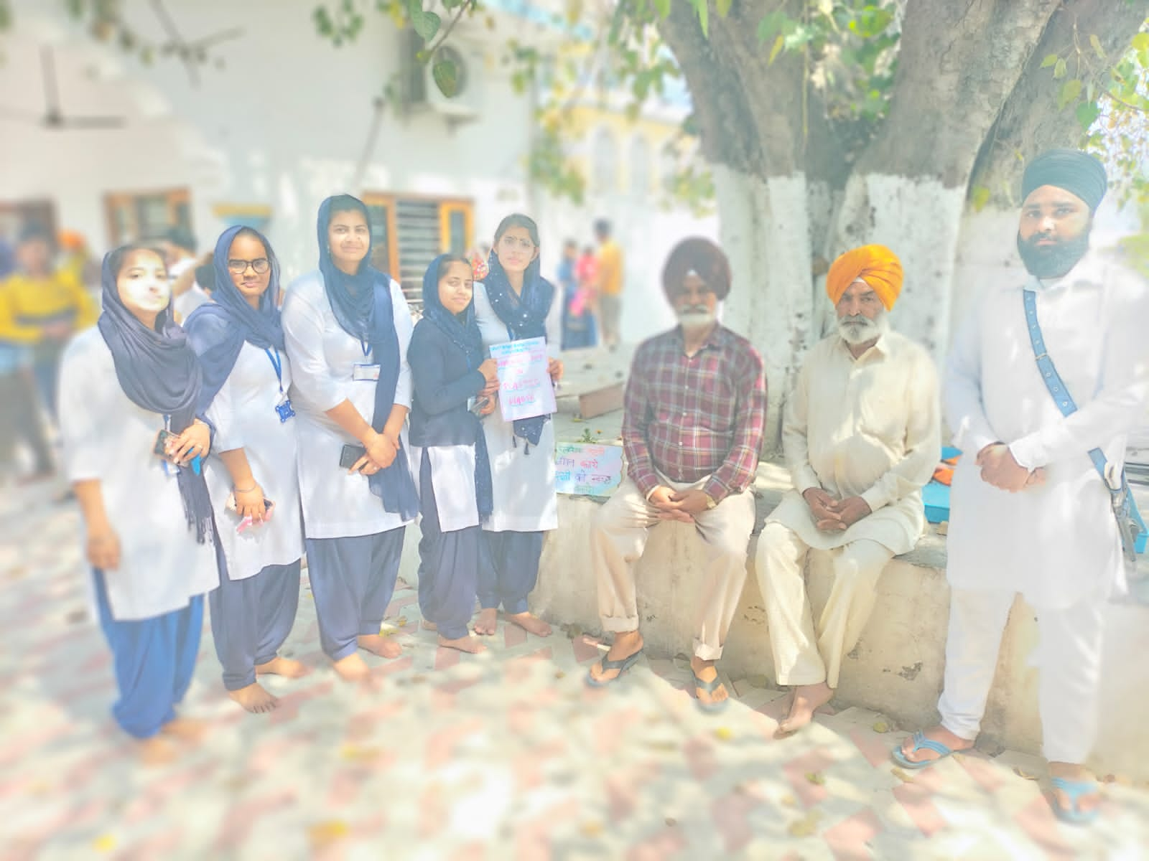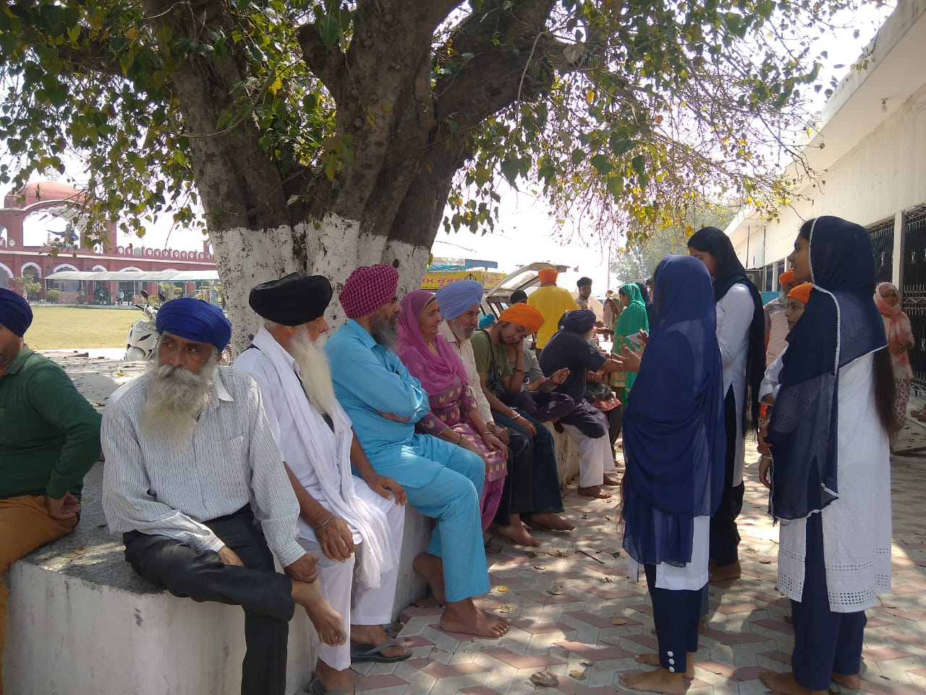

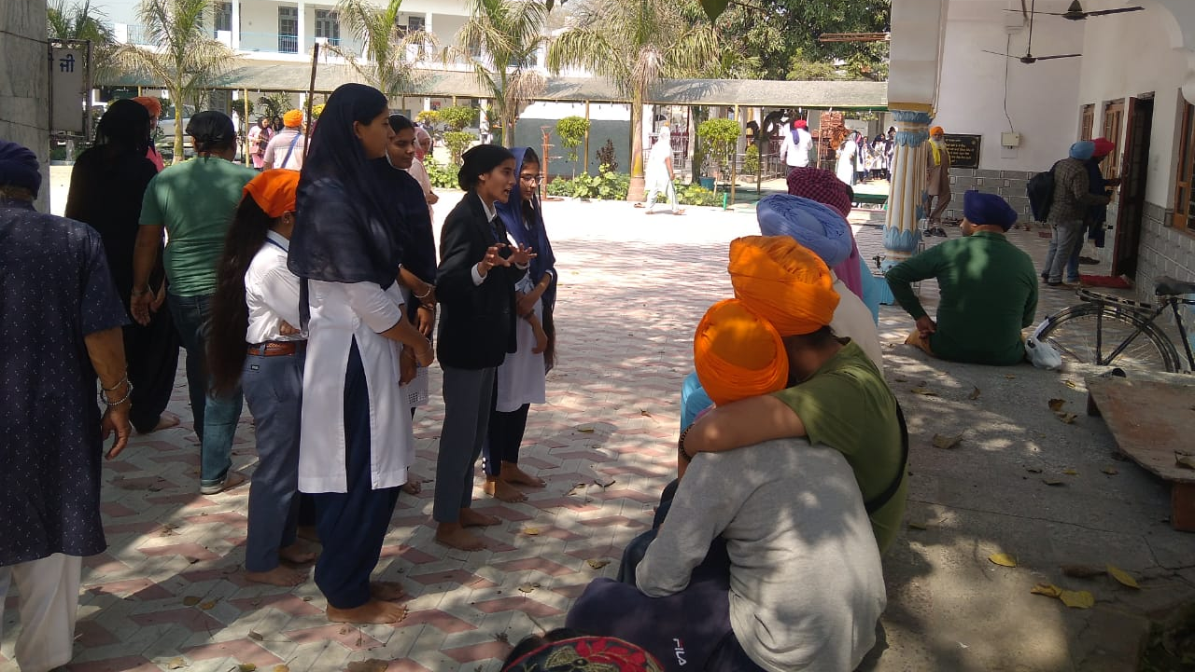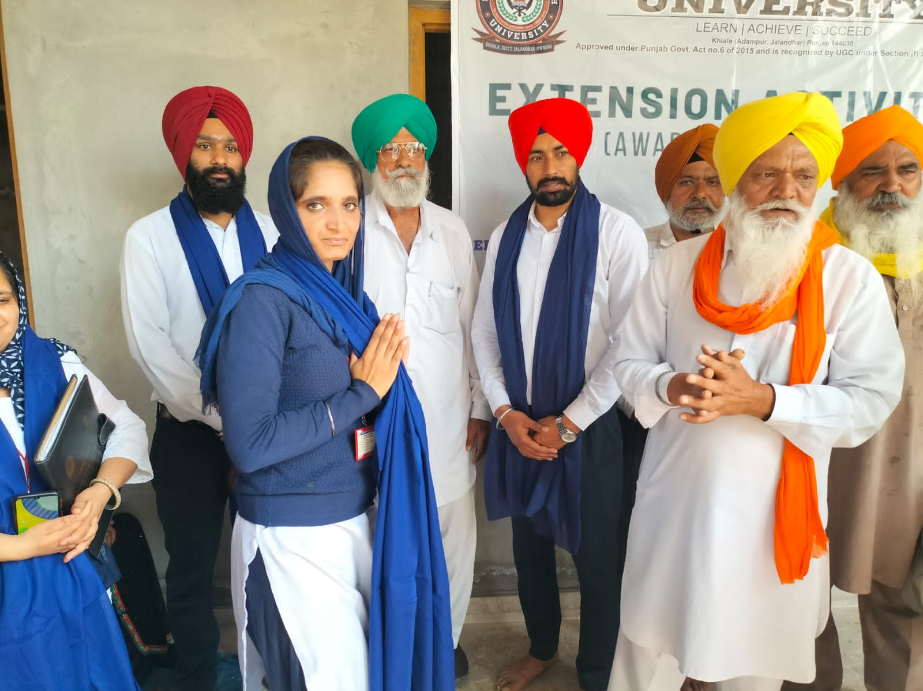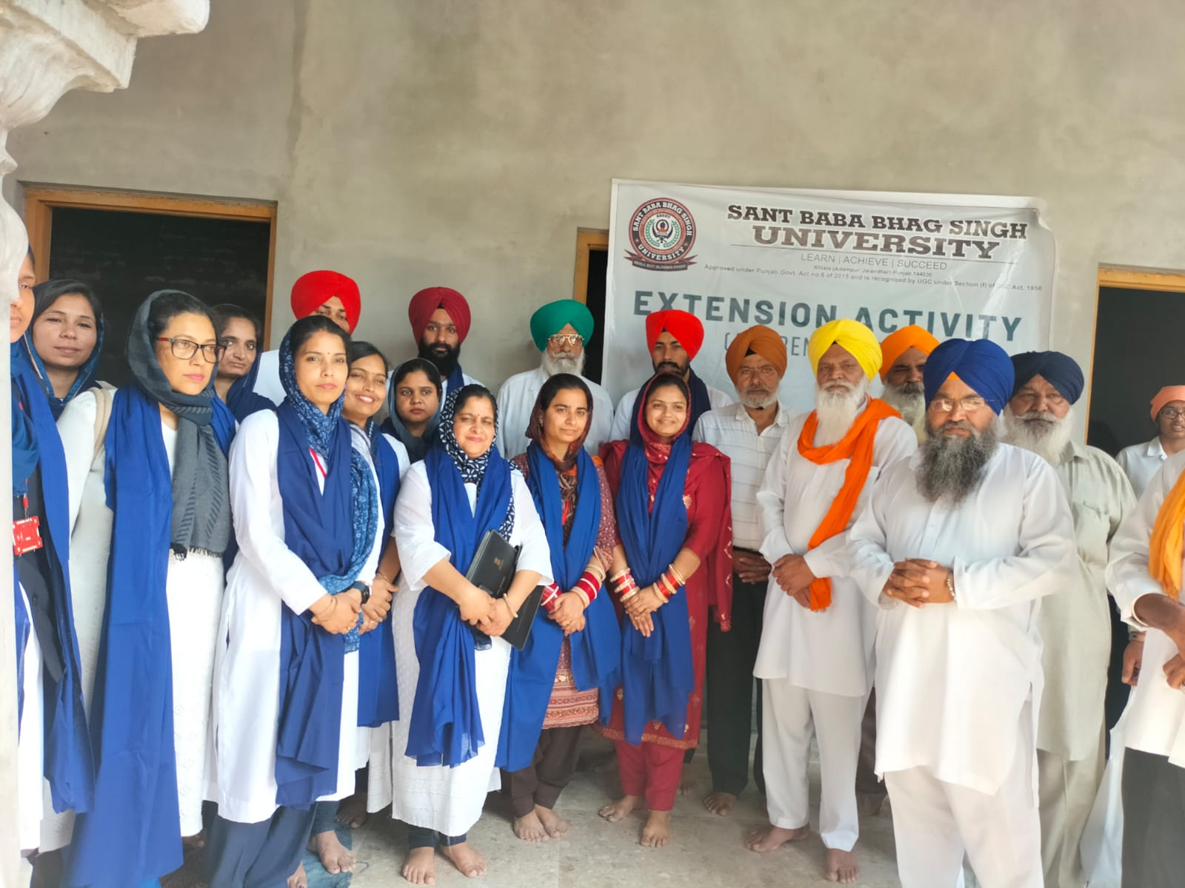

Activity Incharge (Physical Sciences)

Dr. Nisha Sharma
(Coordinator, Physical Sciences)

